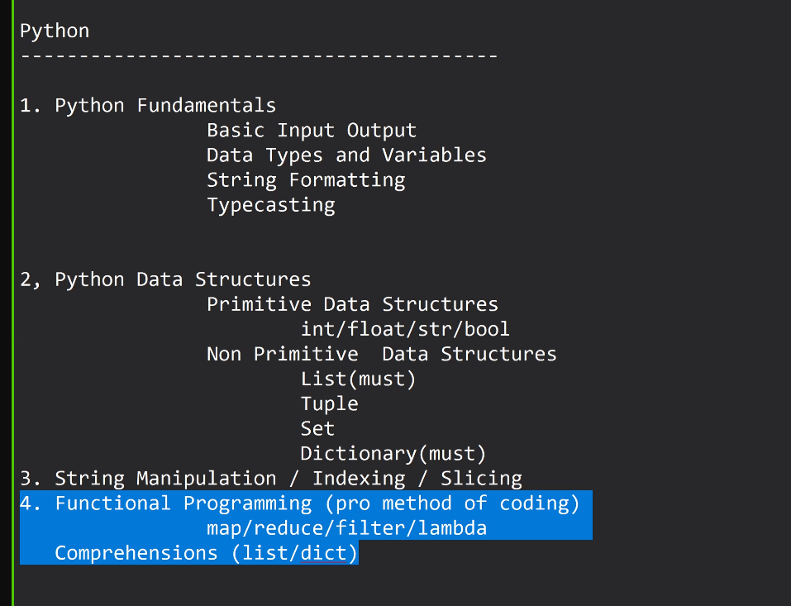
Python
------------------------------------------

5. Flask –
API Development / Route
Working with JSON
REST API
HTTP Method (Put / Get / Post / Delete)
HTTP Error Codes Eg 401 / 500 / 404 / 301

6. OOP (basics are at least suggested) eg. Class and Object
How can you prepare ?
W3schools
Pynative.com
https://pynative.com/python-exercises-with-solutions/

Python
-----------------------------------------
- Python Fundamentals
Basic Input Output
Data Types and Variables
String Formatting
Typecasting
2, Python Data Structures
Primitive Data Structures
int/float/str/bool
Non Primitive Data Structures
List(must)
Tuple
Set
Dictionary(must)
3. String Manipulation / Indexing / Slicing
4. Functional Programming (pro method of coding)
map/reduce/filter/lambda
Comprehensions (list/dict)
5. Flask
API Development / Routing
Working with JSON
REST API
HTTP Methods(post/get/put/delete)
HTTP ERROR CODES eg. 401 / 500 / 404 / 301
6. OOP (basics are aleast suggested) eg. classes Objects.

